**Assessing The Influence of Instagram Influencer Marketing on Follower Buying Intentions**

**Faraz Adzandri**

Fakultas Pariwisata dan Perhotelan, Universitas Negeri Padang

*Email:* [*farazadzandri2506@gmail.com*](mailto:farazadzandri2506@gmail.com)

**Feri Ferdian**

Fakultas Pariwisata dan Perhotelan, Universitas Negeri Padang

*Email:* [*feri_ferdian@fpp.unp.ac.id*](mailto:feri_ferdian@fpp.unp.ac.id)

*Author correspondence:* [*farazadzandri2506@gmail.com*](mailto:farazadzandri2506@gmail.com)

***Abstract****. This study explores the relationship between influencer marketing and the buying intention among @tinandbel followers. This study was motivated by the* ***Incompatibilities*** *between the content published about @tinandbel's dining experience at the restaurant and the* ***observed lack of a significant increase*** *in customer numbers. This study's research methodology included quantitative techniques with a causal associative approach in addition to purposive sampling, which produced 120 samples. The data gathering approach uses a questionnaire with a Likert scale structure that has undergone validity and reliability assessments. With a percentage value of 65%, the R-squared results demonstrate that influencer marketing significantly affects purchase intention; the remaining 35% is accounted for by other factors. The hypothesis test results revealed a t-statistic of 12.13 > 1.96 and a p-value of 0.00 < 0.05, indicating that influencer marketing characteristics had a substantial impact on buying intention. These findings support the study's findings. According to the study's findings, Ha is accepted whereas H0 is denied.*

***Keywords****: Influencer Marketing, Buying Intention, Instagram*

**INTRODUCTION**

The explosion of digital technology has drastically reshaped our lives. In response to the fast-paced advancements of Industry 4.0, Japan introduced a novel concept called Society 5.0 at the World Economic Forum in Davos, Switzerland, back in early 2019. As (Fukuyama, 2018) explains, Society 5.0 envisions a future where technology seamlessly integrates with everyday life to address social challenges. This human-centric approach leverages digital tools but prioritizes human ingenuity. Society 5.0, also known as the super smart society, aims to tackle social issues by fostering a deep connection between the digital and physical worlds.

Buying intention, as defined by(Kotler & Keller, 2012) is a component of consumer behavior that attempts to guide the decision-making process when purchasing goods or services, where people actively participate in obtaining and utilizing the goods or services given. In the meantime, buying intention, as defined by (Amelia Ibnu Wasiat & Bertuah, 2022), is a problem-solving strategy used in the context of buying goods or services, where people search for solutions to satisfy the needs and wants of consumers. The term "buying intention" describes a customer's willingness to make a purchase. People use their knowledge, experience, and outside information to evaluate products as the first step in the Buying Intention process (Jufrizen et al., 2020).

As stated by (Purwaningwulan et al., 2019)bias nowadays eventually reduces labor costs when producing goods. One example is the emergence of the Instagram app, which makes business-related activities easier and more convenient without requiring physical return home. Nowadays, the public can connect with many types of characters through digital platforms, particularly Instagram and social media influencers. Many people use Instagram as a business tool by posting high-quality photos of their products (Wulandari & Darma, 2020). According to the following graph, as of January 2024, the number of Instagram users in Indonesia reached 89.891.300, or 31.9% of the total population.

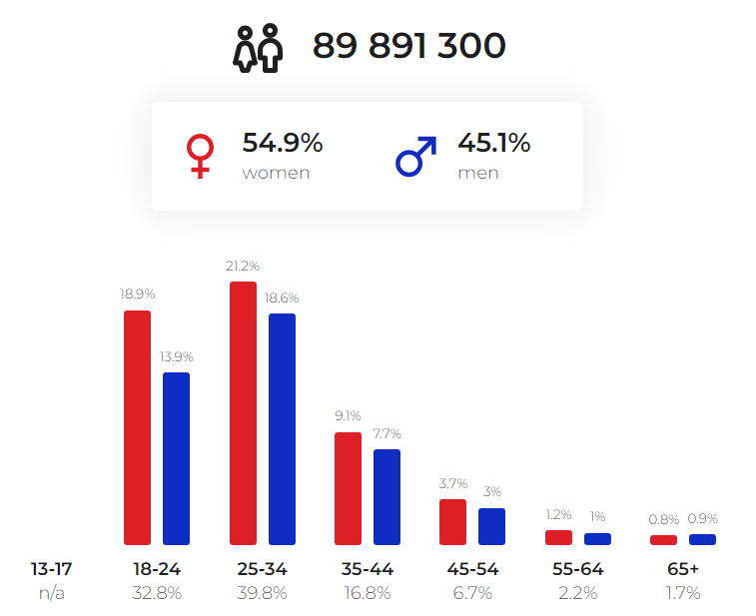

**Image 1.** Number of Instagram Users in Indonesia by Age Range

January 2024

Source: [www.napoleoncat.com](http://www.napoleoncat.com) (2024)

Influencer marketing is a subset of digital marketing, which has emerged as a major new marketing strategy in the last ten years, particularly for professionals who play a major influence in the decision to buy. The ability to have an impact on people, things, or events is a broad definition of "influence" (Biaudet & Forsström, 2017). An influencer is a person who, by virtue of their position, relationships, power, or knowledge, can affect other people's purchase decisions.

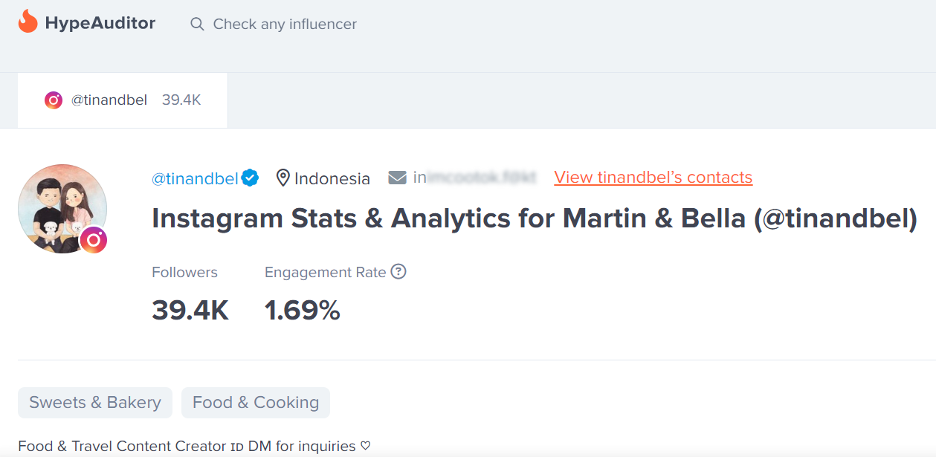

**Image 2.** Enggagement Rate Instagram @tinandbel

*Source: Hypeauditor.com (2024)*

One such marketing tactic is influencer marketing. In partnership with a restaurant, @tinandbel is given a dining experience in exchange for the influencer's endorsement. Afterwards, @tinandbel can use various mediums, including pictures, videos and reviews, to share their dining experience at the restaurant on social media.

A number of indications, including transaction interest, reference interest, preference interest, and exploration interest, can be used to determine buying intention. In this instance, viewers who exhibit these four characteristics and contemplate or intend to purchase the advertised good or service in the future might be considered to have been successfully influenced to make a purchase.  
The capacity to draw attention through eye-catching visual content, the influencer's authority in a given industry that fosters brand loyalty and trust, their skill at spreading knowledge, and their capacity to offer insightful information to the public that shapes attitudes and purchases are all examples of influencer marketing indicators. The content generated through influencer marketing can trigger the buying intention of the people who view the content. The research framework can provide direction and guidance in the research process. In this study, Influencer Marketing is the independent variable (X) and Buying Intention viewers @tinandbel on Instagram as the dependent variable (Y).

The purpose of this study is to determine how influencer marketing affects buying intentions of @tinandbel followers. Previous studies on the subject have mostly concentrated on buying intentions (Johansen et al., 2017) and influencer marketing (Biaudet & Forsström, 2017). Furthermore, research has been done on the impact of influencer marketing on purchase intentions (Lengkawati & Saputra, 2021). Additionally, not much research has been done on buying intention and influencer marketing. i) How does influencer marketing affect buyingintentions of @tinandbel followers? ii) Does influencer marketing affect followers propensity to purchase after seing @tinandbel content?

**LITERATURE REVIEW**

The theory of purchase intention is employed to forecast an individual's desire to act in a particular manner. This is accomplished by evaluating an individual's attitude toward a certain conduct in addition to subjective norms that can affect an individual's attitude within an individual or group. A person's interpretation of the opinions held by those in their immediate social circle, including parents, friends, and coworkers, shapes their subjective norms. Due to our preconceived notions about how other people will respond to and whether we will accept our conduct, we are influenced by subjective standards (Aliyar & Mutambala, 2015).

Consumers show buying interest in a product in various ways. Setianingsih & Nurhadi (2016) identified several indicators, such as: interest in buying after receiving product information (transaction interest), desire to recommend products to others (reference interest), prioritization of certain products (preference interest), and actively seeking information and positive things about the product (exploration interest). In short, purchase intention is an important indicator for companies to understand consumer behavior and create effective marketing strategies.

Influencer marketing, a subset of digital marketing, has become a major strategy in the past decade. It leverages the power of individuals with established online followings to influence consumer purchasing decisions. In essence, "influence" refers to the ability to impact people's choices (Biaudet & Forsström, 2017).

Ki & Kim, (2019) identified several key indicators for evaluating influencer marketing effectiveness: attention-grabbing ability, influencer authority, influencer expertise, and influencer informativeness. Effective influencers can capture audience attention through engaging content, establish credibility as experts in their field, provide valuable information, and ultimately influence consumer behavior. These indicators emphasize the importance of selecting influencers who can effectively connect with, inform, and persuade their target audience to achieve successful influencer marketing campaigns.

**METHOD**

The study at hand utilizes a descriptive quantitative technique and a causal associative strategy to investigate the correlation between influencer marketing and buying intention. The 184 followers of @tinandbel who liked the content up until April 2024 made up the research population. Based on predetermined criteria, 120 respondents were chosen through the use of purposeful sampling. The following is a description of the respondents based on the study's findings: Of the sample, 49 respondents were male and 71 were female; the majority (50.8%) were in the 26–33 age range, 30% were in the 18–25 age range, 18.3% were in the 34–41 age range, and 0.8% were over 41.

The most current educational levels reached were elementary school (0%), junior high school (0%), high school (41.7%), and university (58.3%). Employment groups with incomes of less than Rp 1,000,000 (2.5%), Rp 1,000,000 to Rp 2,000,000 (6.7%), Rp 2,000,000 to Rp 3,500,000 (17.5%), and others (5%), which include housewives (5%), civil servants (5%), private workers (45%), state apparatus (22.5%), self-employed (17.5%), and others (5%). The percentages are Rp 3,500,000 to Rp 5,000,000 (48.3%) and Rp 5,000,000 and above (25%). Throughout the whole research process, ethical issues were prioritized in order to guarantee transparency and confidentiality. For the purpose of ensuring validity and correctness, the data analysis employed partial least square structural equation modeling. The study's conclusions may be helpful in understanding how @tinandbel's followers' purchasing intentions are influenced by influencer marketing.

**FINDING AND DISCUSSION**

**Finding**

1. **Measurement Model**

The results of the reflective measurement model, which comprise outer loadings, indicator reliabilities, composite reliabilities, AVE values, and Cronbach's Alpha values, are shown in Image 3 and table 1. The measurement model assessment is employed to appraise the structure's validity and dependability.

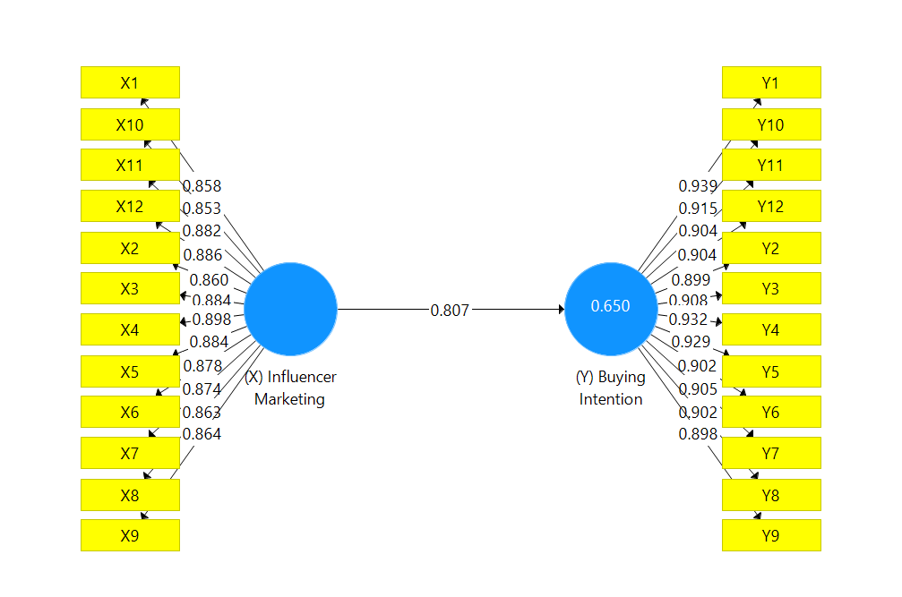

**Image 3.** Measurement Model

The measurement model displayed in Image 3 summarizes the study's findings. Each indicator has an outer loading value larger than 0.7 and every construct has an average variance extract (AVE) value greater than 0.5. (Hair et al., 2017). This section presents a measurement strategy to investigate the relationship between buying intention and @tinandbel's influencer marketing.

*Table 1. Reflective Measurement Model*

|  |  |  |  |  |  |
| --- | --- | --- | --- | --- | --- |
| **Latent Variabel** | **Indicators** | **Outer Loadings** | **Cronbach Alpha** | **Composite Reliability** | **AVE** |
| **Influencer Marketing** | IM1 | 0.858 | 0.972 | 0.975 | 0.763 |
| IM2 | 0.860 |  |  |  |
| IM3 | 0.884 |  |  |  |
| IM4 | 0.898 |  |  |  |
| IM5 | 0.884 |  |  |  |
| IM6 | 0.878 |  |  |  |
| IM7 | 0.874 |  |  |  |
| IM8 | 0.863 |  |  |  |
| IM9 | 0.864 |  |  |  |
| IM10 | 0.853 |  |  |  |
| IM11 | 0.882 |  |  |  |
| IM12 | 0.886 |  |  |  |
| **Buying Intention** | BI1 | 0.939 | 0.982 | 0.983 | 0.831 |
| BI2 | 0.899 |  |  |  |
| BI3 | 0.908 |  |  |  |
| BI4 | 0.932 |  |  |  |
| BI5 | 0.929 |  |  |  |
| BI6 | 0.902 |  |  |  |
| BI7 | 0.905 |  |  |  |
| BI8 | 0.905 |  |  |  |
| BI9 | 0..898 |  |  |  |
| BI10 | 0.915 |  |  |  |
| BI11 | 0.904 |  |  |  |
| BI12 | 0.904 |  |  |  |

Furthermore, the measuring model that was used to collect the data from the respondents has strong convergent validity, as shown by the AVE values. Influencer marketing has an AVE of 0.763, which is rather high. Meanwhile, purchasing intention meets the required minimum of 0.50 as well, with an AVE value of 0.831. These outcomes demonstrate how precise and dependable the data collected was.

The excellent influencer marketing and purchase intent of @tinandbel followers are amply demonstrated by Table 1. These elements' respective Cronbach's Alpha ratings of 0.972 and 0.982 amply indicate the high degree of internal consistency reliability that these components exhibit. Additionally, composite reliability scores of 0.983 for purchase intention and 0.975 for influencer marketing support this dependability. The fact that all item loadings fell between 0.780 and 0.917, suggesting strong indicator dependability, lends further credence to the results. To sum up, Table 1 presents a smart and captivating representation of the exceptional quality and reliability of influencer marketing, together with the purchase intent of @tinandbel followers.

The measurement model evaluation included Heterotrait-Monotrait Ratio of Correlations (HTMT) analysis to assess discriminant validity. Based on Table 2's data, there is no indication that the HTMT values (HTMT criterion <0.90) have a discriminant validity problem.

*Table 2. HTMT Assessment*

|  |  |
| --- | --- |
|  | **Heterotrait-monotrait ratio (HTMT)** |
| **Influencer Marketing <-> Revisit Intention** | 0.821 |

1. **Structural Model**

In the context of PLS-SEM analysis, the application of route analysis or structural models to the provided hypothesis serves as an extra evaluation. The purpose of this study is to investigate the connection between followers of @tinandbel's purchase intentions and influencer marketing.

The structural model in table 3 displays the path coefficient. The significance level of the hypothesis as established by the Bootstrapping results and the t-statistic value. Take note that the route coefficient is considered satisfactory when the significance level is at least 95% confidence.

*Table 3. Path coefficient, T-statistics and significance levels*

|  |  |  |  |  |
| --- | --- | --- | --- | --- |
| **Path Analysis** | **Path Coefficient B** | **T Statistics** | **P Values** | **Result** |
| **Influencer Marketing -> Buying Intention** | 0.807 | 12.130 | 0.000 | Accept |
|  | **Notes: *p<. 05. **p<.01. ***p<0.001** | | | |

The path coefficient for the hypothesis (β = 0.807, t = 12.130, p = 0.000) indicates that influencer marketing has a positive effect on buying intention.

*Table 4. The effect size, R2, Q2 Statistics*

|  |  |  |  |  |
| --- | --- | --- | --- | --- |
| **Path Analysis** | **f2 Buying Intention** | **Effect Size** | **R2** | **Q2** |
| **Influencer Marketing** | 1.861 | Substantial | 0.650 | 0.533 |
| **Notes: f2 values of 0.02=weak; 0.15=moderate; and 0.35=substantial** | | | | |

The data in Table 4 showed a substantial degree of variability (R2 = 0.650) among @tinandbel followers, which may be explained by the first-level predictors of the proposed model. This study also looked into the predictive relevance, effect size, and coefficient of determination. The findings indicate a robust relationship between purchase intention and influencer marketing. The study's modest predictive model is indicated by the purchase intention Q2 value of 0.533. In this instance, influencer marketing affects the followers of @tinandbel's intention to buy.

**Discussion**

About the outcomes of using SPSS version 20 to process data from 120 respondents. The overall influencer marketing variable is known to fall between 3.41 and 4.20, with a value of 4.07, indicating that it is good. The Influencer Authority indicator receives the lowest assessment (3.94%) in the fairly good category. This indicates that the quality of the content produced has not prompted followers to try the same dining experience. Therefore, content delivery needs to be improved to make it easier for followers to comprehend the content and feel motivated to purchase.

Based on data processing results from 120 respondents using SPSS version 20, it is known that the overall range of 3.41-4.20 for the Buying Intention variable may be classified as good, with a total value of 3.87. The Reference Interest indicator, which has the lowest rating in the good category with a score of 3.70, indicates that the restaurant advertised through @tinandbel's material has not been described, which incentivizes its followers to share information about the restaurant. In order to encourage the audience to contribute knowledge, it is necessary to make as many adjustments as possible to the information presented so that it is easily understood and instructive.

Based on the results of the study's testing and data processing, the path coefficients with the original sample value of 0.807 were generated. This shows a positive number with a t-statistic value of 12.130 larger than the t-table value of 1.96 and a p-value of 0.000 less than 0.5. Because the Influencer Marketing (X) variable affects the Buying Intention (Y) variable, it may be concluded that Ha is allowed and H0 is rejected. The purchase intention variable's r-square value is 0.650, which indicates that 35% of buying intention is impacted by other factors and 65% of buying intention is influenced by the influencer marketing variable, per the results of the structural model evaluation.

These findings show that the more effectively @tinandbel uses influencer marketing, the more followers it will have who are willing to make purchases. When followers see content from @tinandbel, they will designate the restaurant as their favorite and top choice, indicating that they are happy with the dining experience and will tell others about it. This theory is supported by a study titled ‘Pengaruh Influencer Marketing Terhadap Keputusan Pembelian (Studi Pada Elzatta Hijab Garut)’ conducted by (Lengkawati & Saputra, 2021). The study found that influencer marketing has a positive impact on consumer purchasing decisions.The study explains that influencer marketing has an impact on the ups and downs of purchasing decisions in the sense that if the influencer marketing strategy can be improved, purchasing decisions will also increase and vice versa.

**CONCLUSION AND SUGGESTION**

With a score of 4.04, this study determined that the influencer marketing campaign run by @tinandbel at Lobo & Juno Restaurant is rated as good. With a score of 3.87, this has a favorable effect on buying intention, indicating a strong category as well. Using Smart PLS version 3.0, the impact of Influencer Marketing on Buying Intention was quantified, yielding an r-square value of 0.650. This indicates that Influencer Marketing accounts for 65% of the influence on Buying Intention at Lobo & Juno Restaurant, with other factors accounting for the remaining 35%. This suggests that Lobo & Juno Restaurant can increase Buy Intention with Influencer Marketing @tinandbel on Instagram.

Several suggestions are made to Influencer @tinandbel based on the research findings in order to improve the efficacy of Influencer Marketing and attain more ideal outcomes in raising Buying Intention at Lobo & Juno Restaurant. These recommendations are: Boost Influencer Authority: In order to increase his followers' interest in experiencing the places he reviews, @tinandbel needs to better his ability to entice them to do so by improving a number of factors. Boost Buying Intention: In order to enhance the likelihood that its followers will have Buying Intention, @tinandbel must innovate and come up with fresh ideas for reviews and content. By putting these tips into practice, @tinandbel should be able to boost buying intention at Lobo & Juno Restaurant and attain more ideal results in their Influencer Marketing.

**REFERENCE**

Aliyar, S., & Mutambala, C. (2015). *Consumers’ online purchase intention in cosmetic products*.

Amelia Ibnu Wasiat, F., & Bertuah, E. (2022). Pengaruh Digital Marketing, Social Media Influencer Terhadap Niat Beli Produk Fashion Pada Generasi Milenial Melalui Customer Online Review di Instagram. *SINOMIKA Journal: Publikasi Ilmiah Bidang Ekonomi Dan Akuntansi*, *1*(3), 513–532. https://doi.org/10.54443/sinomika.v1i3.295

Biaudet, S., & Forsström, M. (2017). *Title: Influencer Marketing as a Marketing Tool-The Process of Creating an Influencer Marketing Campaign on Instagram Supervisor (Arcada)*.

Fukuyama, M. (2018). *Digital Transformation*. http://www8.cao.go.jp/cstp/

Hair, J., Hollingsworth, C. L., Randolph, A. B., & Chong, A. Y. L. (2017). An updated and expanded assessment of PLS-SEM in information systems research. *Industrial Management & Data Systems*, *117*(3), 442–458. https://doi.org/10.1108/IMDS-04-2016-0130

Johansen, I. K., Sveberg, C., Supervisor, G., & Hem, L. E. (2017). *Influencer Marketing and Purchase Intentions How does influencer marketing affect purchase intentions?*

Jufrizen, J., Daulay, R., Sari, M., & Nasution, M. I. (2020). MODEL EMPIRIS PENINGKATAN KEPUASAN DAN NIAT BELI KONSUMEN DALAM PEMILIHAN ONLINE SHOP INSTAGRAM. *MIX: JURNAL ILMIAH MANAJEMEN*, *10*(2), 249. https://doi.org/10.22441/mix.2020.v10i2.008

Ki, C. ‘Chloe,’ & Kim, Y. (2019). The mechanism by which social media influencers persuade consumers: The role of consumers’ desire to mimic. *Psychology & Marketing*, *36*(10), 905–922. https://doi.org/10.1002/mar.21244

Kotler, P., & Keller, K. L. (2012). *Marketing Management*.

Lengkawati, A. S., & Saputra, T. Q. (2021). *PENGARUH INFLUENCER MARKETING TERHADAP KEPUTUSAN PEMBELIAN (STUDI PADA ELZATTA HIJAB GARUT)*.

Muhammad Alfarisyi, & Feri Ferdian. (2023). Guest Decision To Book A Hotel Room Through Social Media : The Mediation Effect Of Behavioural Intention. *Gemawisata: Jurnal Ilmiah Pariwisata*, *19*(2), 01–18. https://doi.org/10.56910/gemawisata.v19i2.307

Purwaningwulan, M. M., Suryana, A., Wahyudin, U., & Dida, S. (2019). *The Existence of Social Media as a Promotional Media in The Hijab Image Revolution in Indonesia*. https://digitalcommons.unl.edu/libphilprac

Setianingsih, N. F., & Nurhadi. (2016). *THE INFLUENCE OF PRICE PERCEPTION, PRODUCT DIVERSITY, AND STORE ATMOSPHERE TOWARD PURCHASE DECISION (Case Study At Dunkin Donuts Consumer In Ambarukmo Plaza Yogyakarta*. www.suratpembaca.web.id

Wulandari, L. P. A., & Darma, G. S. (2020). *ADVERTISING EFFECTIVENESS IN PURCHASING DECISION ON INSTAGRAM*.

Zikri, M. A., Weldy, A. S., Ananda, E. R., & Ferdian, F. (2023). Visitors’ Subjective Well Being: The Effect of the Motivational Sharing Travel Photos Through Instagram. *Journal of Business on Hospitality and Tourism*, *9*(1), 35. https://doi.org/10.22334/jbhost.v9i1.449